PROJECT NAME : Comprehensive digital marketing for Mahindra and Mahindra Ltd.

NAME : Jutur Samrin

COLLEGE : Vasavi Mahila Kalasala

UNIVERSITY: Rayalaseema University

MENTOR: DR. Hema sundari

TEAM ID: LTVIP2025TMID21845

INTRODUCTION.

Mahindra & Mahindra Ltd. (M&M) is a leading multinational company in automobiles, farm equipment, and electric vehicles, known for innovation, durability, and sustainability. In today’s digital era, a strong online presence and engagement strategy are crucial for maintaining market leadership.

This digital marketing plan focuses on brand positioning, competitor analysis, audience persona, SEO, content marketing, and content creation, helping Mahindra enhance visibility, drive engagement, and boost sales in a highly competitive market.

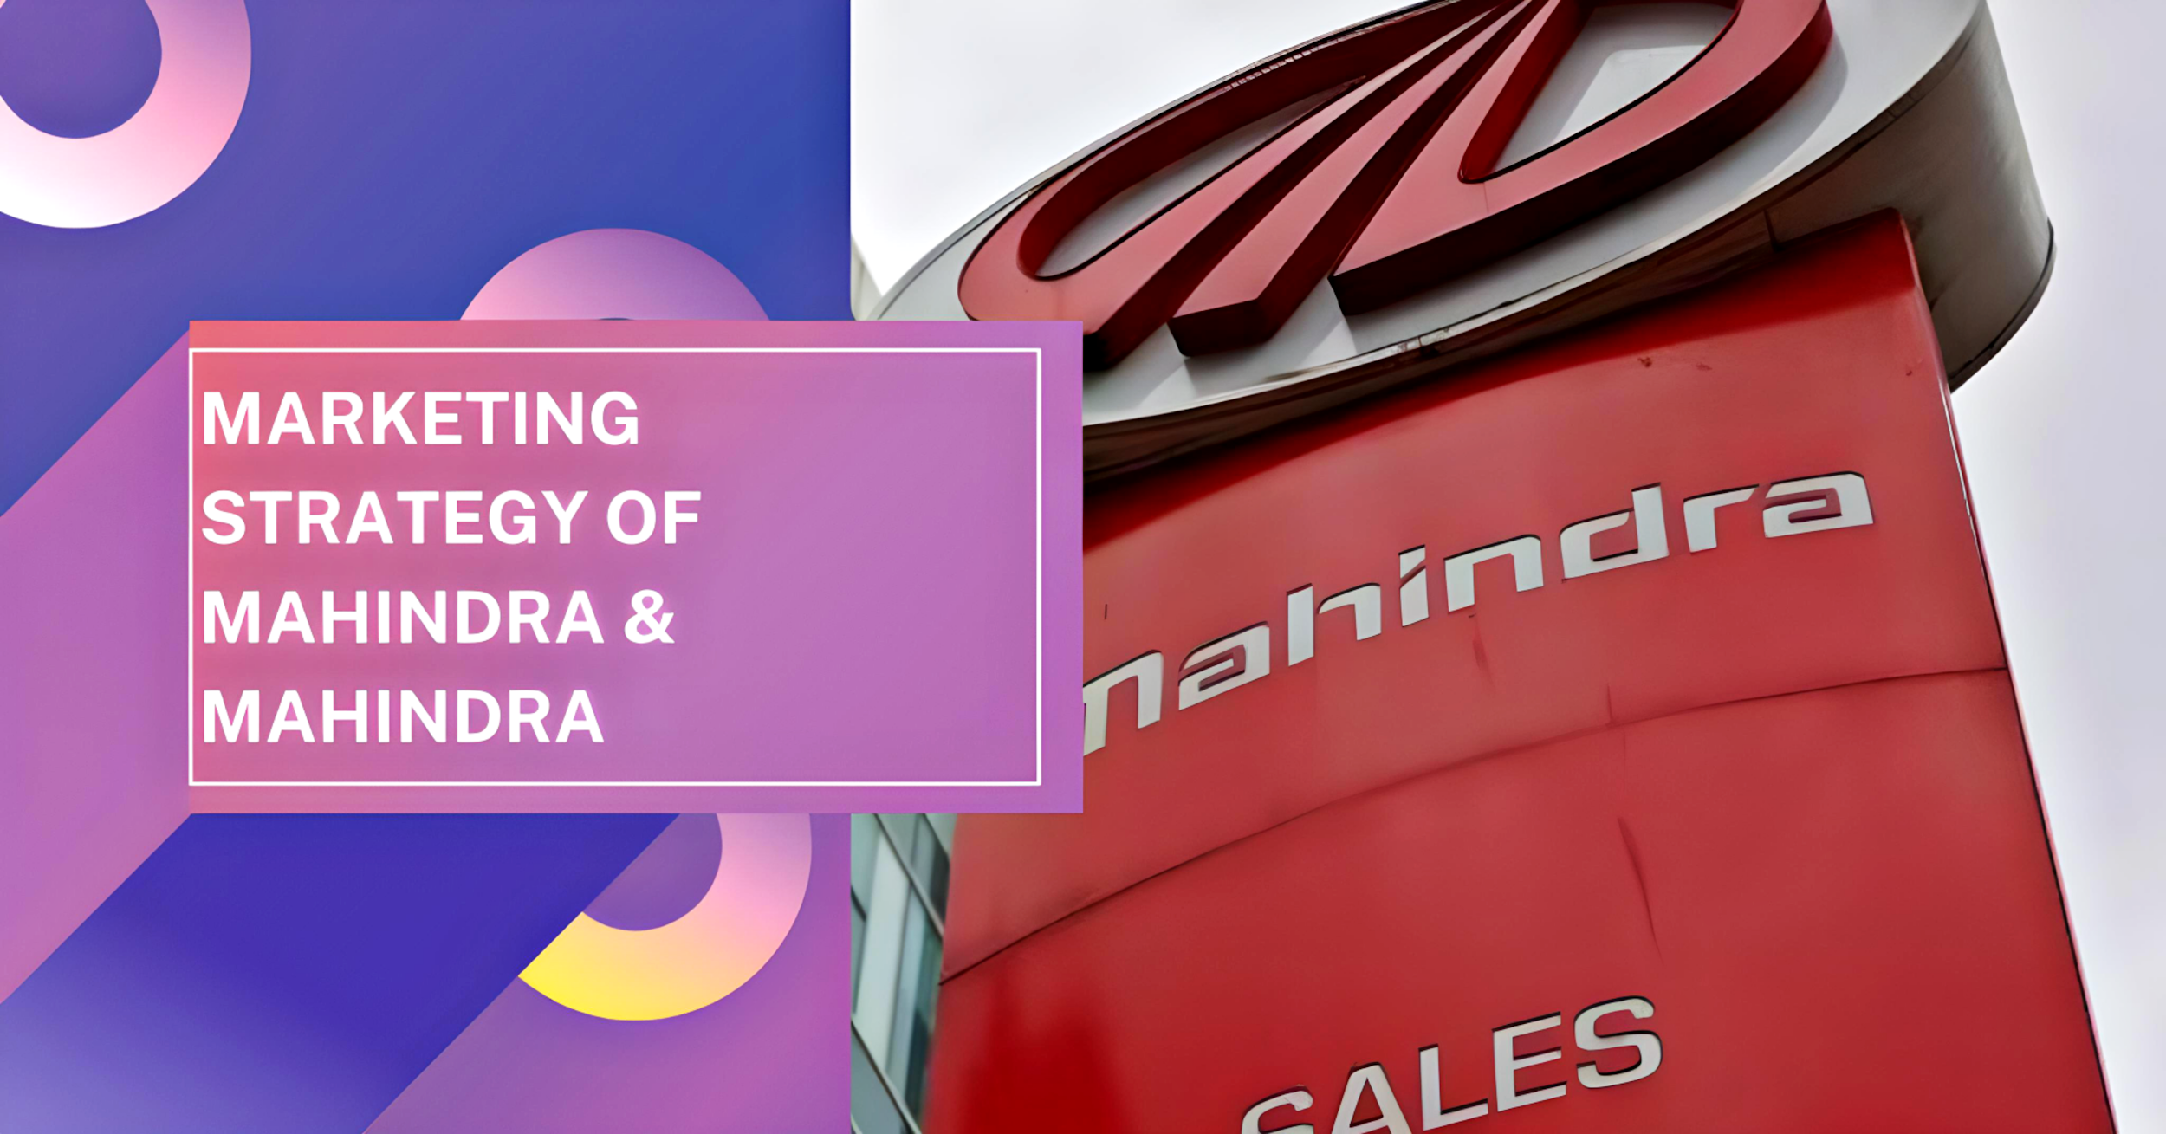

Brand Study

About Mahindra & Mahindra Ltd.

Mahindra & Mahindra Ltd. (M&M) is one of India’s leading multinational companies, operating in industries like automotive, farm equipment, finance, IT, and renewable energy. It is well-known for its SUVs, tractors, electric vehicles, and commercial vehicles, with a strong emphasis on innovation, sustainability, and rural development.

Brand Positioning.

Core Values: Innovation, sustainability, trust, and resilience.

Unique Selling Propositions (USPs):

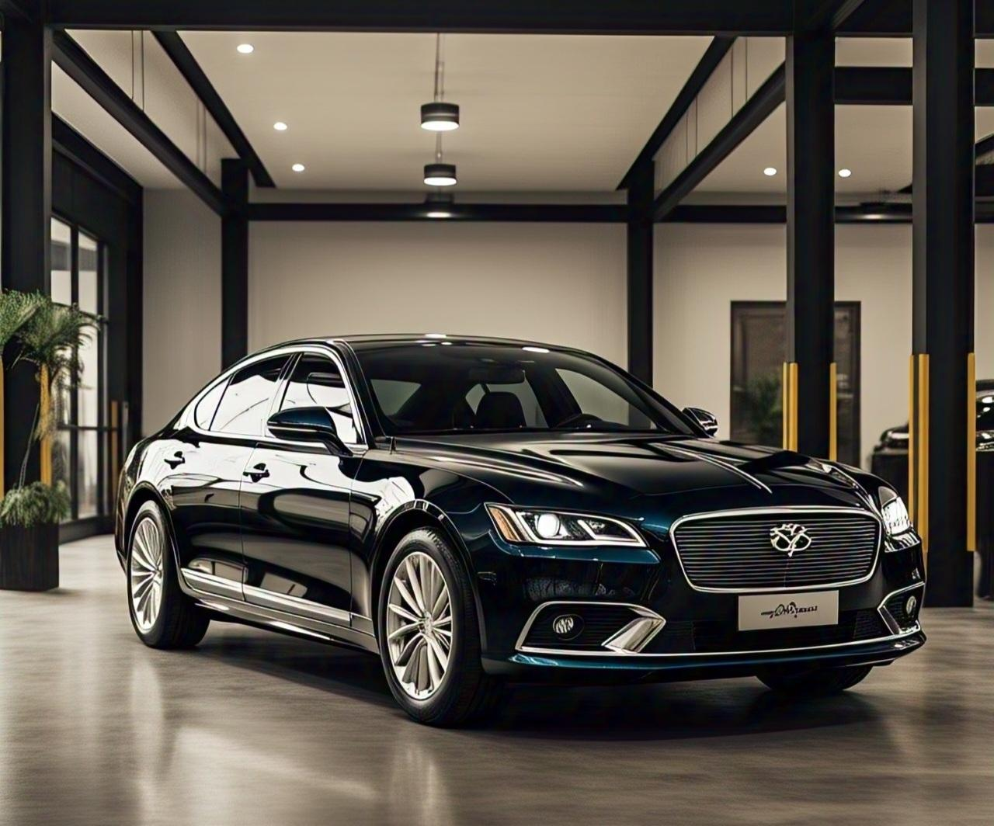

Durable and rugged vehicles suited for Indian roads.

Strong presence in the rural market with best-selling tractors.

Leadership in electric vehicle innovation (e.g., Mahindra XUV400 EV).

Global expansion across various industries.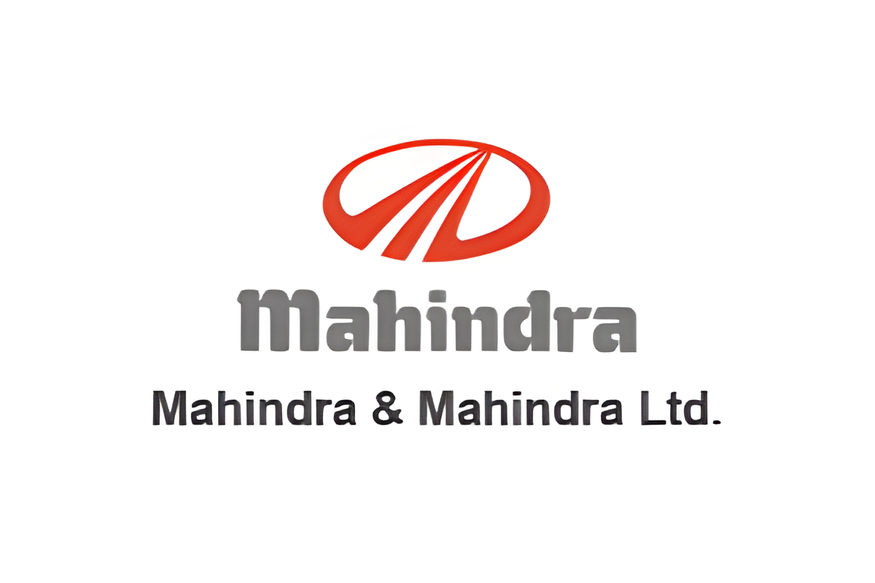

Competitor Analysis.

Key Competitors

1. Automotive Industry:

Tata Motors (SUVs, commercial vehicles, and EVs)

Maruti Suzuki (affordable passenger cars)

Hyundai (urban-focused models and EVs)

MG Motor (EVs and premium SUVs)

2. Tractor & Farm Equipment Industry:

John Deere

Escorts Kubota

New Holland

3. Electric Vehicles:

Tata Motors (Tata Nexon EV, Tigor EV)

MG (MG ZS EV)

Ola Electric (upcoming EV cars)

Competitor Strategies & Insights

Tata Motors: Dominates the EV market with aggressive pricing and strong marketing campaigns.

Maruti Suzuki: Leverages affordability and fuel efficiency as key selling points.

John Deere: Offers technologically advanced tractors targeting premium customers.

MG Motors: Focuses on a tech-savvy urban audience and connected car technology.

Opportunities for Mahindra:

Strengthen the EV lineup with competitive pricing and better infrastructure.

Expand presence in the urban SUV segment (competing with Hyundai Creta, Tata Harrier).

Emphasize agriculture-tech innovations in rural marketing.



Buyer’s/Audience

Persona.

Primary Audience Segments

1. Urban SUV Buyers (Age: 25-45, Middle to Upper Class)

Tech-savvy, values safety and modern design.

Looks for features like connected technology, fuel efficiency, and electric options.

2. Rural Farmers & Agripreneurs (Age: 30-55, Rural & Semi-Urban Areas)

Prioritizes durability, fuel efficiency, and low maintenance in tractors.

Interested in financing options and government subsidies.

3. EV Enthusiasts & Sustainability Advocates (Age: 20-40, Metro & Tier 1 Cities)

Environmentally conscious, willing to invest in green technology.

Concerned about charging infrastructure and battery life.

SEO & Keyword Research.

High-Performing Keywords for Mahindra.

Automotive (SUVs & Cars).

Best SUVs in India 2025.

Mahindra XUV700 vs Tata Harrier comparison.

Affordable electric SUVs in India.

Mahindra Scorpio N price and features

.



Tractors & Farm Equipment

Best tractor for Indian farmers

Mahindra tractor price in India

Top 10 durable tractors for farming

Tractor loans and subsidies in India

Electric Vehicles

Mahindra XUV400 EV range and price

Best electric cars under ₹20 lakhs

EV charging stations near me

Mahindra EV vs Tata Nexon EV

SEO Strategy:

Optimize website and blogs with long-tail keywords.

Improve voice search optimization (e.g., "Which is the best electric SUV in India?").

Focus on local SEO for dealerships and service centers.



Content Ideas & Marketing Strategies.

Content Ideas

Blogs & Articles:

"Top 5 Features of the Mahindra XUV700 That Make It a Game-Changer"

"How Mahindra Tractors Are Revolutionizing Indian Farming"

"Electric Vehicles in India: What Makes Mahindra XUV400 a Smart Choice?”

Video Content:

Behind-the-scenes of Mahindra’s vehicle manufacturing process.

Customer testimonials for SUVs and tractors.

Interactive comparison videos (Mahindra XUV700 vs Tata Safari.

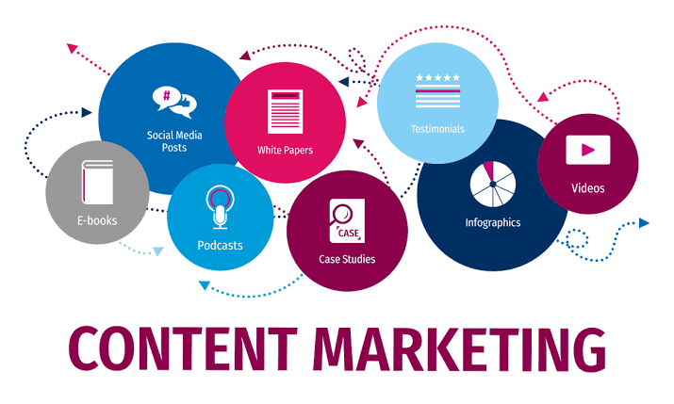

Video Content:

Behind-the-scenes of Mahindra’s vehicle manufacturing process.

Customer testimonials for SUVs and tractors.

Interactive comparison videos (Mahindra XUV700 vs Tata Safari).

Social Media Strategy:

Instagram & Facebook: Short videos, influencer collaborations, and customer stories.

Twitter: Quick updates, industry news, and customer engagement.

LinkedIn: Thought leadership content on sustainability and electric mobility.

YouTube: Explainer videos, test drive experiences, and expert reviews.

Paid Marketing Strategies:

Google Ads & YouTube Ads: Targeting automotive buyers and farmers.

Influencer Collaborations: Partnering with auto experts for reviews.

Facebook & Instagram Ads: Lead generation campaigns for dealerships

Content Creation & Curation.

Content Types & Platforms

Blog Posts (Website & Medium): SEO-optimized, informative content.

Short-Form Video (YouTube Shorts, Instagram Reels, TikTok): Quick highlights and feature showcases.

Infographics (Pinterest & LinkedIn): Market insights, EV benefits, sustainability stats.

Email Marketing (Personalized Newsletters): Offers, new launches, and customer success stories.

Engagement Tactics:

Interactive quizzes (Which Mahindra SUV fits your personality?)

User-generated content campaigns (#MahindraOnTheRoad)

Behind-the-scenes stories from engineers and designers.

